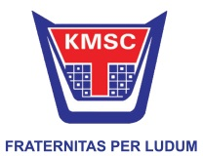

MRF 42nd K1000 Rally 2016

(17th & 18th December 2016)
Reconnaissance Registration
DRIVER:

RECONNAISSANCE CAR MAKE & MODEL:

RECONNAISSANCE CAR REGISTRATION NUMBER:

RECONNAISSANCE CAR COLOUR:

SPARE RECONNAISSANCE CAR MAKE & MODEL:

SPARE RECONNAISSANCE CAR REGISTRATION NUMBER:

SPARE RECONNAISSANCE CAR COLOUR:

Competitor and Team Contact Information

The information contained herein will be confidential to the Organizing Committee of K-1000.

It will be made available to the Police if necessary or be used by the Secretary of the Meeting.

If the Organizing Committee so authorizes. This information may also be used to aid with communication for vehicle recovery.

DRIVER CELLPHONE NUMBER:

CO-DRIVER CELLPHONE NUMBER:

